Week 8 NAME:M.Hemanth

OOPS PROGRAMS CLASS:CSIT

1. ROLL:NO:20R2A333

DATE:4/7/22

import java.io.\*;

import java.util.\*;

class Example

{

public static void main(String[] args)

{

System.out.println("Enter the file name ");

Scanner sc =new Scanner(System.in);

String name =sc.next();

File f=new File(name);

if(f.exists())

{

System.out.println("The name of the file is :"+f.getName());

if(f.canRead())

System.out.println("The file is readable");

else

System.out.println("The file is not readable");

if(f.canWrite())

System.out.println("The file is Writable");

else

System.out.println("The file is not Writable");

System.out.println("The length of the file is "+f.length());

}

else

System.out.println("The file do not exists");

}

}

Output:

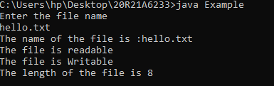

2

import java.util.Scanner;

import java.io.File;

class Example2 { public static void main(String[] args)

{ Scanner scr=new Scanner(System.in);

System.out.println("file names");

File f=new File(".");

String flist[]=f.list();

int c=0;

for(String fname:flist) { File fl=new File(fname);

if(fl.isFile())

System.out.println("file name"+fname);

else if(fl.isDirectory())

System.out.println("Directoary name"+fname);

c++; }

System.out.println("Total Files "+c);

}

}

Output:

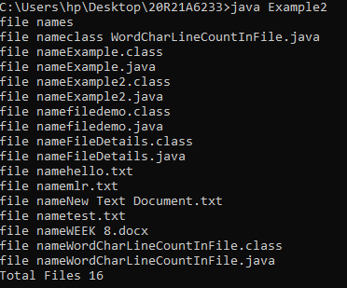

3

import java.io.\*;

import java.util.\*;

class Data { public static void main(String[] args)

{ System.out.println("Enter the file name");

Scanner sc=new Scanner(System.in);

String fname=sc.next();

File f=new File(fname);

if(f.delete()

){ System.out.println("Deleted the file :"+f.getName());}

Else

{ System.out.println("The file "+f.getName()+" does not exist");

} } }

Output:

